Project DNA8 Analyzing Lambdavirus Expression Clones using BLAST and GenBank

Lambda is often used as an vector when constructing cDNA or genomic expression libraries. Random pieces of target DNA are ligated into a unique site behind an inducible promoter in the lambdavirus genome. Then viral coat proteins are added to the DNA, in vitro packaging occurs and you have created a lambda library.

This library of random fragments can be screened by infecting *E. coli* and spreading the infected cells onto agar plates. Individual clones appear as plaques on a lawn of uninfected *E. coli*. Placing a disk of nitrocellulose on the plate will “lift” virus and bacteria onto the membrane which is transferred to a clean plate, grown for several hours then processed. The disk will have been soaked in a chemical that turns on expression from the lambdavirus inducible promoter thus producing protein which adheres to the nitrocellulose.

We can detect a clone expressing the protein of interest by incubating the filter with antibodies against the desired protein (immunoscreening). This is a very powerful and widely used technique. Positive reactions on the nitrocellulose disk can be compared with the plaques on the original plate and the positive plaque identified for further characterization.

Some time ago we plated a library producing 2000+ plaques on each plate and have identified positive clones; in two days we screened 8000-10000 clones. The antibody we are using to detect positive clones is a rabbit antisera against the virus BaCMV. Our goal is to detect viral proteins that we can identify and use as recombinant antigen in diagnostic tests. Proteins can be produced in quantity and inexpensively in *E. coli* and the resulting antigen is non-infectious.

To make the Lambda Tx27 library BaCMV DNA was partially digested with RE *Tsp*509I and cloned into Lambda TriplEx at the *Eco*RI site. The *Tsp*509I enzyme cuts at the site AATT giving a 5'-overhang that is compatible with *Eco*RI sticky ends. Positive clones were selected and DNA produced. The 4 files you have are the result of sequencing through the MCS from the promoter.

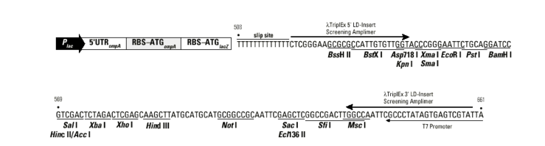

The question is, what viral protein is being expressed?

Objective: Process the trace files to extract useful DNA sequence, as you have in the previous exercises. By searching GenBank you can determine if the expressed DNA has a counterpart in the known sequences.

Problems you will encounter: Duplication, just because they are different clones doesn’t mean they are different DNA’s. Recombination, to convert Lambda TriplEx into a plasmid pTriplEx the virus was passed through a recombinase positive host. Bad things can happen in such an *E. coli* strain.

Data to be produced:

Computer files Acrobat documents

DNA sequence files for each Lambdavirus clone (*.gb) List of possible gene homologs

BLASTX searches for each lambdavirus clone for each lambdavirus clone

## THE END